Hello. Thank you for purchasing the pattern.
To make a product according to this pattern you will need:
-punches with a hole diameter of 1mm with a stitch step of 5 mm or an awl or a single puncher with a diameter of 1mm
- leather outside 1.4-2.0 mm, inside up to 1.4 mm. Only about 60 sq.diameters
- zippers №5 2*45cm and №3 1 – 16cm (metal or plastic)
- zipper mold 210*100mm
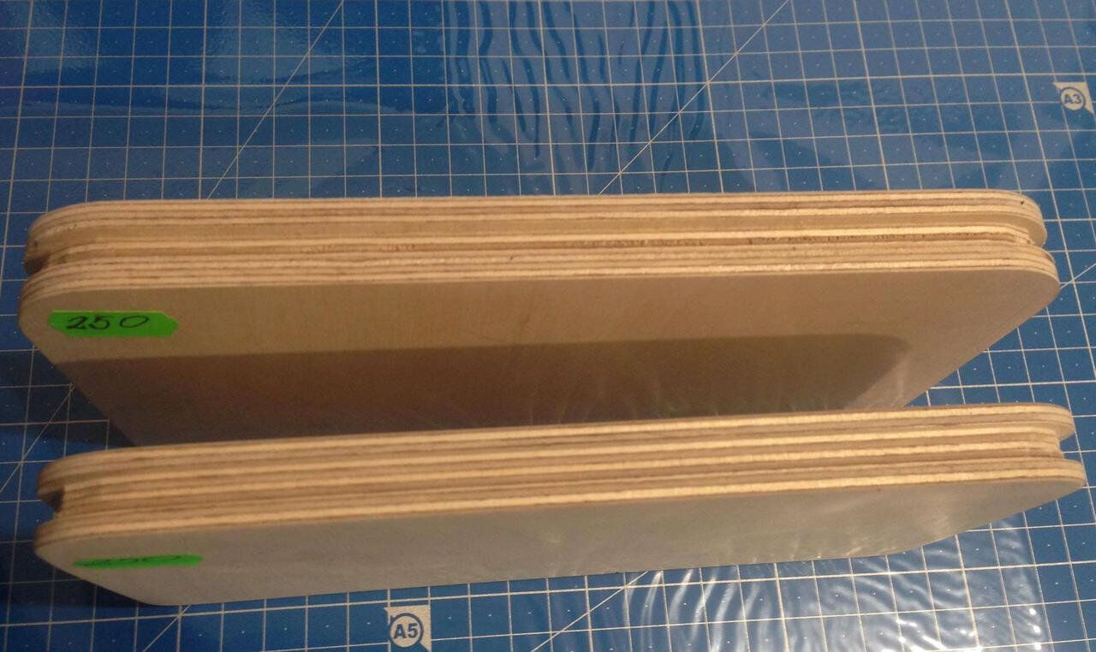
- for linig 1-1.5mm carton and 1-1.5mm softy material
