Printing the pattern
Select print in Adobe Reader- (8.5 x 11 in). Do NOT use the web version of adobe reader to open the files.
Select poster, 100% and Cut Marks:
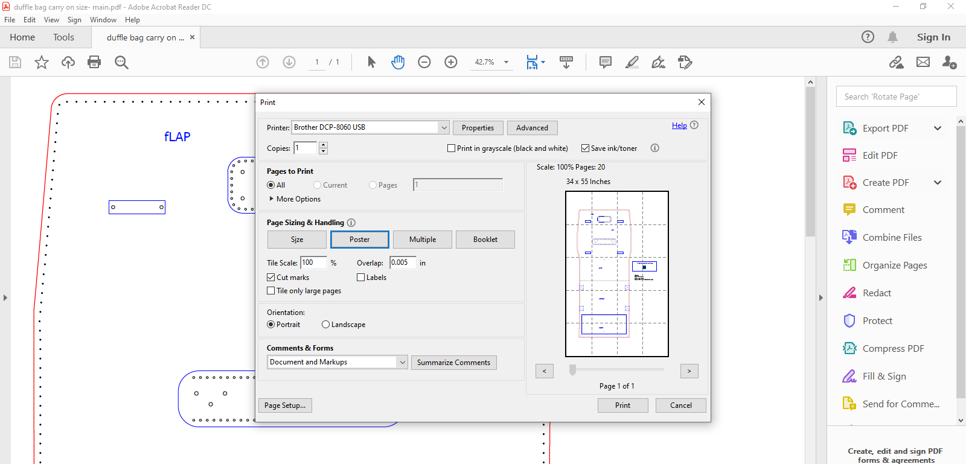

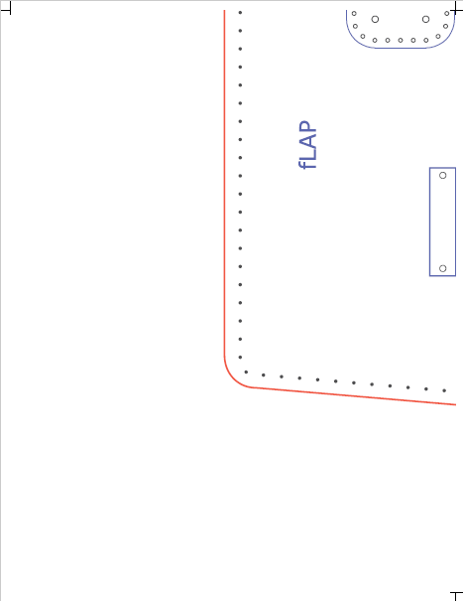
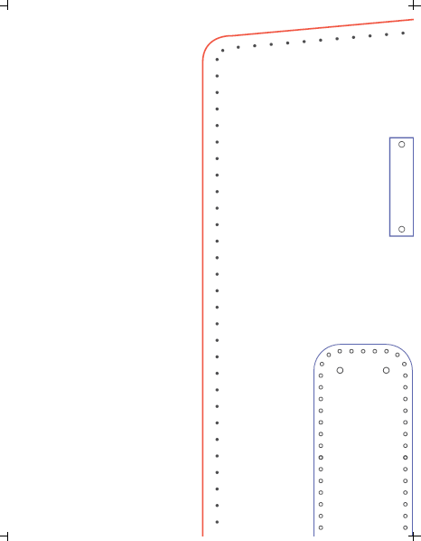
print the pages. Once printed, line up the cut marks and tape together.

